**Annexure: B**

**Reporting Format-B**

**Structure of the Detailed Reporting format**

**(To be submitted by Evaluators to SACS for each TI evaluated with a copy to NACO)**

**Introduction**

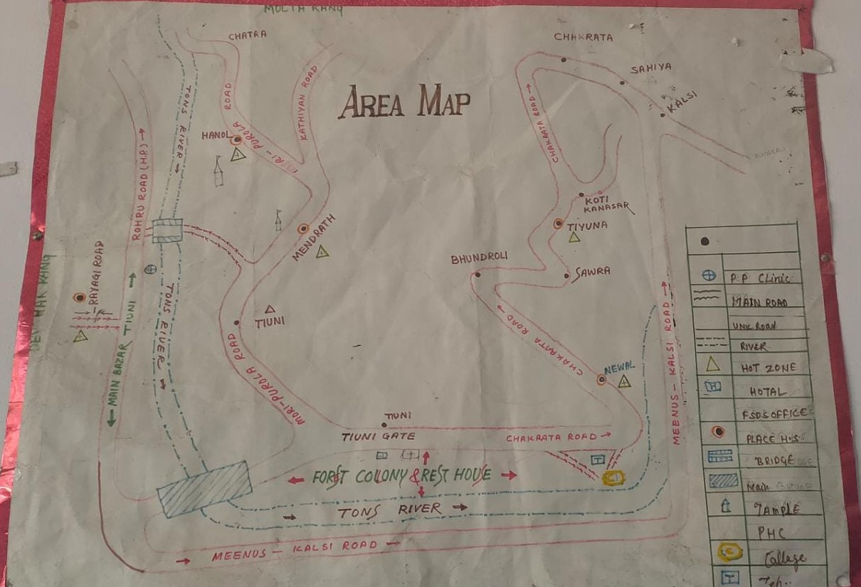

The FSDS organization was established in 1996 with the keen support of social workers.. FSDS is a Secular, Non Profit and Non-Governmental Voluntary Organization working for upliftment and sustainable development of Hilly Area communities since 1996 without discrimination of race, caste, creed, sex, community and religion. The Organization is registered under Societies Registration Act, 1860 having its registration office at district Dehradun

FSDS’s area of operation is District Dehradun ,Uttarkashi ,Chamoli & Tehri, FSDS is actively involved in various community development activities since last 12 year in Block Chakrata & Raipur of District Dehradun with the active support from Government and various non government organization.

We work in the close coordination with the various technological and management organization in strategic planning, human resource etc. We have proven capacities of providing management support services within the social sector. We undertake large and small community development projects such as Implementing Health, Livelihood, Child welfare, Education & Self Funded Environment Awareness & Medicinal Plant Production & Developed Nurseries etc at grass root level.

* **Name and address of the Organization:** Friends of socio Development society(FSDS)
* TI-Office Address: Hanol,Road,Tiuni,chakrata Dehradun
* **Chief Functionary:** Mr. Akhilesh vyas
* **Year of establishment:** 1996
* **Year and month of project initiation: 1st February 2009**

**Profile of TI**

**(Information to be captured)**

* Target Population Profile: **Core Group**
* Target Population Profile: **FSW-250**
* Type of Project: : **Core Group (FSW)**
* Size of Target Group(s): Allocated Target of FSWs- 250, while registered FSWs-391 population active population-360.
* Sub-Groups and their Size: FSW-Home-based (HB-391) ,
* Target Area: TIs’ hotspots stretched in approx.45 kilometers periphery from the TI office,5-Sites and 5 Hotspots.

**Key Findings on Various Project Components**

1. **Organizational support to the programme:**

The organization is running the program successfully in the assigned area and with the population assigned to them. Regular handholding and support provided to the team as per the need of program and capacity enhancement is done at regular interval.

1. **Organizational Capacity**
2. **Human resources: Staffing pattern, laid down reporting and supervision structure and adherence, role and commitment to the project, perspective of the office bearers towards the community at a large staff turnover.**

Staffing pattern is in place as per the norms and staff positions are filled. The supervision is done on regular basis as informed by the beneficiaries during field visits & individual interaction with HRGs/beneficiaries of the project. Despite tough condition and hard to reach areas the commitment of staff is good and they are providing services & support to the beneficiaries at regular interval. The coordination between staff is good and they are supportive to each other. Turnover of PE was seen during this period but that was due to the promotion of PE to ORW position, vacant positions were filled within timeline as stated by the NGO representatives and seen during the review of program.

1. **Capacity building: nature of training conducted, contents and quality of training materials used, documentation of training, impact assessment if any.**

Regular orientation is done by the NGO staff and the senior officials of NGO, handholding support, capacity building is done at regular interval by different staff members for program support & improvement. Documentation is maintained by the TI on regular basis which shows the commitment of the team.

1. **Infrastructure of the organization:**

The organization is having an office in the project area which is rented and located in a central place & it is easy to reach. The DIC is situated in adjacent portion which provides a safe and secure space to HRGs during their visit to DIC as well as they enjoy visiting the DIC.

1. **Documentation and Reporting: Mechanism and adherence to SACS protocols, availability of documents, mechanism of review and action taken if any, timeliness** **of reporting and feedback mechanism, dissemination and sharing of the reports and documents for technical inputs if any.**

Mechanism is in place and adherence to SACS protocols being followed at every level, TI has availability of documents at TI office and it is regularly maintained by the TI staff. Review mechanism is in place and it is regularly done by TI staff & PD. Action is taken by the TI on given feedback or if there’s any finding regarding program/person. Timeliness of reporting is taken care by the TI and feedback mechanism is in place. Reports are prepared, shared and disseminated by the TI at regular interval & timeliness is followed. If technical input is required it is being taken care by the TI .

1. **Program Deliverables –**

**Outreach**

1. **Line listing of the HRG by category.**

Line listing of the population is as per the norms of SACS/NACO and it is documented by the TI which is reviewed by the evaluation team during the evaluation visit. The TI is working with FSW population and the records are updated as well.

Allocated Target of FSWs- 250, while registered FSW population is -391 the active population is -360.

1. **Registration of migrants from 3 service sources i.e. STI clinics, DIC and Counseling**
2. **Registration of truckers from 2 service sources i.e. STI clinics and counseling**
3. **Micro planning in place and the same is reflected in Quality and documentation.**

Micro planning is done at TI level, it is a regular process and done by the TI team on regular basis for service delivery. Micro planning helps in service delivery, gap identification and addressing the gaps on regular basis. The documents were reviewed during the evaluation visit.

1. **Coverage of target population (sub-group wise): Target / regular contacts**

Coverage of target population is on regular basis which is reviewed during the field visit of evaluation team and meeting with HRGs also helped us to understand the interaction & service delivery from TI side. The beneficiaries appreciated the support from TI and accepted that they are getting commodities & services on regular basis, PE/ORW/PM & counsellor is visiting and providing them support as and when needed.

1. **Outreach planning – quality, documentation and reflection in implementation**

Outreach planning is done by the and it is reflected in day to day activities of TI and the documents were available at TI. The outreach plan also reflect in the service delivery and other support services.

1. **PE: HRG ratio**

PE:HRG ratio is maintained as per the guidelines but it is seen that the distribution was not even due to the area & size of the population.

1. **Regular contacts (as contacting the community members by the outreach workers /Peers at-least twice a month and providing services such as condoms and other referral services) - understanding among the project staff, reflection in impact among the community members**

Regular contact with community members was visible during the meetings with community and discussing the visits, services & support of TI team. The staff of TI has clarity about their roles and responsibilities and day to day activities of TI at office & field level. Community members were having some personal health which they discussed during our field visit it is also an impact of confidence between TI team & community.

1. **Documentation of the peer educators**

Peer level documents were available at TI and the peers are also carrying their diary for referral and documenting the ongoing activities on daily basis.

1. **Quality of peer education- messages, skills and reflection in the community**

Peers are good in delivering the desired message regarding services, safety, personal care & providing with TI related program services to them. The community know them well as they are from community and have close association with each other.

We were able to meet more than 40 women in meeting and some of them in one to one interaction during our field visits.

1. **Supervision- mechanism, process, follow-up in action taken etc.**

The mechanism is in place and process is followed by the TI team. At some point issues were discussed and as per the need action is taken and issue is resolved by the TI team and management body of the NGO.

1. **Services-**
2. **Availability of STI services – mode of delivery, adequacy to the needs of the community**

STI services are given to the community members as an when it is reported through PPP doctors, community need was addressed by the TI but few cases need referral to higher facilities for better treatment as the first line of medicines have impacted for short term and again there are complaints from the community member about STI again.

During the field visit we have suggested the community member to visit the doctor for examination and diagnosis so the treatment can be initiated.

1. **Quality of the services- infrastructure (clinic, equipment etc.), location of the clinic, availability of STI drugs and maintenance of privacy etc.**

Every norm is followed by the TI and staff is very careful about the privacy during the visit to clinic. Clinic is located in a location which is accessible to the community. STI drug was available in TI kit 5 was short and it is reported to SACS for procurement. Shortage of drugs was reported by TI to SACS.

1. **In case of migrants and truckers the STI drugs are to be purchased by the target population, whether there is a system of procurement and availability of quality drugs with use of revolving funds.**
2. **Quality of treatment in the service provisioning- adherence to syndromic treatment protocol, follow up mechanism and adherence, referrals to VCTC, ART, DOTS centre and Community care centers**

The TI is aware of service provisioning and adherence to syndromic treatment protocol is done.

1. **Documentation- Availability of treatment registers, referral slips, follow up cards (as applicable- mentioned in the proposal), stock register for medicines, documents reflecting presence of system for procurement of medicines as endorsed by NACO/SACS and the supporting official documents in this regard.**

The TI is working in this field for a long time and have all the records at TI level. Prescribed formats were available at TI level & updated regularly by the staff.

1. **Availability of Condoms- Type of distribution channel, accessibility, adequacy etc**

Condom was available at TI and regular distribution is done by the PE. The community is able to visit the TI and PE is distributing the condoms at community level as per the need & demand of HRG.

Stock out has been reported by TI during this evaluation period.

1. **No. of condoms distributed- No. of condoms distributed through different channels/regular contacts.**

The TI is regularly distributing the condoms at community level, during the evaluation period against the demand of 84398, distribution was 62523 which is nearly 75% of the demand. Distribution channel is established and regular contact, out let DIC are the different distribution channels.

1. **No. of Needles / Syringes distributed through outreach / DIC**
2. **Information on linkages for ICTC, DOT, ART,STI clinics**

Linkages are established with different service providers at district level. Since the services are given through CBS testing and PPP clinics TI staff randomly visit the CHC.

1. **Referrals and follows up**

Mechanism in place and referral is done as per the need. Good follow up mechanism due to close contacts between the PE & community.

1. **Community participation**
2. **Collectivization activities: No. of SHGs/Community groups/CBOs formed since inception, of these groups towards the project activities**

SHGs are formed and currently 8 SHGs are functional as reported by the TI. Women groups are formed and supported by the TI.

1. **Community participation in project activities- level and extent of participation, reflection of the same in the activities and documents**

TI has groups in which community members are engaged in project related activities, management committee for TI program has number of community members to provide regular support, monitor & provide feedback to the TI for improvement.

1. **Linkages**
2. **Financial systems and procedures**
3. **Systems of planning: Existence and adherence to NGO-CBO guidelines/ any approved systems endorsed by SACS/NACO- supporting official communication.**

***The organization is in practice to incur expenditure according to the approved budget except Under Infrastructure & Administration head a sum of Rs 2800 has been utilized to pay office rent from Office Expenses Rs 800/- and from Documentation cost / BCC material Rs 2000 .***

1. **Systems of payments- Existence and adherence of payments endorsed by SACS/NACO, availability and practice of using printed and serialized vouchers, approval systems and norms, verification of documents with minutes, quotations, bills, vouchers, stock and issue registers, practice of settling of advances before making further payments**.

***On the basis of the test check conducted by us it was found that the NGO is in practice to use printed and machine numbered vouchers. Vouchers are signed by the accountant and sometimes approved by the Project Director. They are supported with the bills/ details. But on some occasions it was found that vouchers are not supported with proper bills.***

***Stock registers for stationery items is being maintained but not properly maintained.***

1. **Systems of procurement- Existence and adherence of systems and mechanism of procurement as endorsed by SACS/NACO, adherence of WHO-GMP practices for procurement of medicines, systems of quality checking**.

**As per the statement of Accountant purchase is made from the firms nominated by the Management Committee of the organization and it requires no quotation process. But no purchase policy could be shown at the time of visit.**

1. **Systems of documentation- Availability of bank accounts(maintained jointly, reconciliation made monthly basis), audit reports**

***NGO is maintaining a separate current bank account with State Bank of India A/c no*** 30824088250 at Tyuni.

***The said account is being operated jointly by the Project Director and President of the organization and Accountant. Bank Reconciliation Statement is being prepared on a monthly basis.***

***The organization has attended audit observations raised by the Auditor.***

1. **Competency of the project staff**

**VIII a. Project Manager –** The project manager was working with the TI for long time and have resigned from her position in January due to ill health (she is suffering from typhoid). She was competent and hard working. She has a good reputation at community level and has the knowledge & understanding of program. She is trained by SACS/NACO on program management & indicators. Project Manager is appointed as per the guidelines of SACS/NACO.

**PM position is vacant and advertisement is floated for this position and very soon this position will be filled as ensured by the PD TI.**

**VIII b. Counselor-** Counselor is hard working and supporting the TI program very well. She is good in nature and providing field level services and support on regular basis. Service delivery, counselling and handholding support is regular. Documents are maintained at TI level & outreach is done by her.

**VIII c. ANM/Counselor in IDU TI**

**Not applicable**

**VIII d. ORW-** TI has 2 sanctioned position and both the ORWs are in place. One PE is promoted as ORW recently due to a vacant position. **One more ORW is needed considering the tough conditions and stretch of the field in the hills.**

**VIII e. Peer Educators –** 4 sanctioned position in TI and it is filled as per the norms, they are from community. One new PE joined recently and was oriented by the TI team about the program. **2 more Pes are required for the TI as the conditions are tough in this area.**

.

**VIII f. Peer Educators in IDU TI**

**VIII g. Peer Educators in Migrant Projects**

**VIII h. Peer Educators in Truckers Project**

**VIII i. M & E Officer**

**The M&E –**

**M&E position is vacant and advertisement is floated for this position and very soon this position will be filled as ensured by the PD TI.**

**IX a. Outreach activity in Core TI Project**

Outreach planning is regular as per the need & outreach activity plan is prepared by the TI and it is reflected in day to day activities of TI. Outreach activities are done according to the plan and it is documented, the documents were available at TI. The outreach activity plan also reflects in the service delivery and other support services.

**IX b. Outreach activity in Truckers and Migrant Project Interact with all PEs and ORWs to understand whether the number of outreach sessions conducted by the team is reflecting in service uptake that is whether enough clinic footfalls, Counseling is happening. Whether the stake holders are aware of the outreach sessions. Whether the timings of the outreach sessions are convenient / appropriate for the truckers/migrants when they can be approached etc.**

**X. Services-**

Regular services are provided to the community and community accepted that they are regularly provided with the services.

**XI. Community involvement:** Community involvement in project is visible and seen during visit and meeting with the community.

**XII. Commodities:**

Regular supply of commodity is ensured by the TI but there were shortage of condoms, kits were reported during the evaluation period.

**XIII. Enabling environment:**

Women of community are motivated to collectivize themselves through SHGs and individually skill development is also done which is not noted or recorded.

Financial literacy, legal literacy, digital literacy and enabling for human rights was focused by the TI which helped lot of community members & their family.

**XIV. Social protection schemes/innovation at project level HRG availed welfare schemes, social entitlements, etc.**

The project had provided support to the community in availing various social protection schemes/ welfare schemes/social entitlements.

|  |  |  |
| --- | --- | --- |
| Sr. No. | Scheme Name | No. Of Beneficiaries |
| 1) | Aadhar Card | 250 |
| 2) | Pradhan Mantri Jan Dhan Yojana | 185 |
| 3) | PAN Card | 75 |
| 4) | Internal Road Sanction Follow up | |
| 5) | Gharkul Awas Yojana Form Filling & submission | |
| 6) | Voting Card | 250 |
| 7) | Water Supply Connection Follow up | |
| 8) | Opening Balwadi for young kids | |
| 9) | Ration Card | 250 |

**XV. Best Practices if any:**

The TI is working in this area for long time and the community support & trust is one of the best visible outcome is seen during this evaluation period.

The TI helped community in leveling of a ground for young kids which is a good gesture towards changing the mindset of community & society at large.

**Annexure C**

**Confidential**

**Reporting form -C**

**EXECUTIVE SUMMARY OF THE EVALUATION**

|  |  |
| --- | --- |
| **Name of the Evaluators** | **Contact Details with phone no.** |
| **Mr. Akash Mishra** | [**asmishra1971@gmail.com**](mailto:asmishra1971@gmail.com) **09140348485** |
| **Mr. Mohan Pant** | [**Mohanpant.09@gmail.com**](mailto:Mohanpant.09@gmail.com) **7579427236** |
| **Mr. Arun Ruhela** | [ca.arunruhela@gmail.com](mailto:ca.arunruhela@gmail.com) 9410146352 |

|  |  |
| --- | --- |
| **Name of the NGO:** | FSDS - TIUNI |
| **Typology of the target population:** | FSW |
| **Total population being covered against target:** | Typology Target Achievement    **FSW** 250 360 active/319 Reg. |
| **Dates of Visit**: | 21-23th February, 2022 |
| **Place of Visit:** | Hanol Road,Tiuni,  Chakrata - Dehradun |

**Overall Rating based programme delivery score:**

|  |  |  |  |
| --- | --- | --- | --- |
| **Total Score Obtained (in %)** | **Category** | **Rating** | **Recommendations** |
| Below 40% | D | Poor | Recommended for |
| 41%-60% | C | Average | Recommended for Continuation |
| 61%-80% | B | Good | Recommended for Continuation |
| **>80%** | **A** | **Very Good** | **Recommended for continuation.** |

**Specific Recommendations: Recommended for continuation with these recommendations:**

|  |
| --- |
| * Documentation should be more specific with the use of data for strategy development. * Issue based advocacy meeting to be planned more frequently with different stakeholders. * The community mobilization activity need to be increased. More community members to be given opportunity in different Committees as members and should be given specific responsibilities or can be involved in activities. * **Recommended to provide additional man power, 1 ORW & 2 PE considering the tough conditions of the area .** |

|  |  |
| --- | --- |
| **Name of the Evaluators** | **Signature** |
| **Mr. Akash Mishra (Team Leader)** |  |
| **Mr. Mohan Pant (Co - Evaluator)** |  |
| **Mr. Arun Ruhela (CA-Finance Expert)** |  |