**Reporting Format-B**

**Structure of the Detailed Reporting format**

(To be submitted by Evaluators to SACS for each TI evaluated with a copy NACO)

Introduction

* Name and address of the Organization-**Balajee Sewa Sansthan**
* Background of Project:- Migrant-15000, Trucker-5000, Transit-5000
* Chief Functionary- Mr.Awadhesh Kumar
* Year of establishment- Regn. No. 453/2002-03 dated 3-9 2002. Patna, Bihar (Societies Act 21 of 1860)
* Year and month of project initiation- 1-4-2011
* Evaluation team- Prof.-Jagendra Singh Rawat Team Leader

- Mr.Harpal Singh Program

- Mr.Arun Ruhela Finance

* Evaluation Timeframe-21-2-2022 to 23-2-2022

Profile of TI

(Information to be captured)

* Target Population Profile: Migrant, Trucker, Transit
* Type of Project: BridgeNA
* Size of Target Group(s) NA
* Sub-Groups and their Size NA
* Target Area-16

Key Findings and recommendations on Various Project Components

1. **OBJECTIVES** –
2. To extend outreach services with 100% of population
3. To provide BCC services 100 % community for safer sex practices
4. To prevent and cure STIs among 60-100% of targeted population.
5. To ensure 60-100 % HIV testing of HRG two time in a year..
6. To promote safer sex practices among 100% HRG population.
7. To create enabling environment among all Stake Holders at project area of TI project.
8. To establish linkages with care and support services for PLHA among target population.
9. To mobilize HRG community for developing ownership

**Major activities:**

**The targeted intervention activities are well defined in the project as mentioned in the initial project. However, the focus of the project would be on the following:**

**COMPONENTWISE PROJECT ACTIVITIES: -**

To achieves the above objective, we will implement following activities among the targeted population

1. **Behavior Change Communication :–**
   * **One to One session:** Project has 6.locations which covered by 15PLs. Each PL has caters to at least 100 HRG locations. Considering 2O day’s visit in a month and each PL will conduct at least 20 one to one sessions in a month, hence to cover all targeted PLs they would be able to cover all HRG once in three months. ORW will necessarily attend at least 5 such one to one sessions of each PL.
   * **Community meeting/Group meeting and discussion with groups:** It is expected that during ORW visit in the field at least 3 community/group meetings in each PL area will be conducted. Some of the meeting would be conducted along with PLs and necessarily be conducted without PL to assess the access and involvement of PLs. Similarly Counselor/PM will have to necessarily attend at least 1 such meetings of each PL besides counseling in the field.

* + **Condom demo and re-demo:** PLs during one to one session condom demo will be done by PL with all new HRGs. During each one to one session attended by ORW condom demo will be conducted again by ORW especially for all new HRGs and HRGs having high clientele.
  + **Wall Painting & leaflets distribution:** Under BCC activities local need based IEC material will be developed especially to focus HRGs and their clientele for reduction of unsafe sex and STI care & tests. Wall writing will be done under IEC head separate from prescribed budget according to local cost and sites. However, all the important site will be covered.

**Follow-up** & **Counseling:**  one to one counseling by the counselor at least 30 HRGs in each PL area. All the HIV & AIDs positive will be covered necessarily at least every three months for follow-up visit.

1. **STI Management–**

* **Selection, mapping & training of preferred provider’s zone wise:** All the sites are mapped. PPs in every site to ensure presently working in the project and other 2 more PPs are to be identified and trained this year.
* **Rapport building & linkages with service providers:** Besides PP services government facilities. Two major facilities available in the project testing & treatment. Besides, this mobile services running Selaqui need to be linked to cover highway clients.
* **Counsel and orient the Preferred Provider (PP):** PP will be counseled and oriented on TI roles, process of STI services. An agreement will be worked out with each PP on payment conditions and service to be provided to HRGs.
* **Develop medicine KIT according to guide line of NACO:** Medicine will be purchased for STI as per GMP/WHO list from licensed dealer. The indent of the medicine will be prepared with consultation of PPs and according to requirement of Kits as prescribed for each type of problem.
* **Counseling and referral of HRG to preferred provider:** Regular group discussion and one to one with HRGs will be done by the counselor and he will refer HRGs to the preferred provider for, Syphilis screening as well as to the nearest government facilities. Counselor wills regularly follow-up the frequency of, tests of category of HRGs and ensure the regular check-up.

1. **Condom promotion:–**

* **Gap analysis of condom usage:**
* Identification and selection of outlets.
* Procurement of Condom.
* Demonstration on condom Use.
* Condom re-demonstration.
* Establishment of condom outlets.
* Social Marketing through ORW, PL and outlets.
* Follow up
* Training on negotiation skills.
* Reporting & Documentation.

1. **Community Mobilization :–**

* Meeting at hot spot level.
* Establishing of DIC.
* Meeting at DIC level.
* Community event
* Reporting & Documentation

1. **Enabling Environment:-**

* Stakeholders Analysis
* Stake holder level meeting
* Setting up network and linkages with other services providers
* Networking meeting with service providers
* Advocacy and linkages with line departments.
* Observation of important Days (World AIDS day, Women day, Childers day etc)
* 1 day Advocacy – cum –sensitization workshop with media person, Health department, local leaders, police department. NGOS)

1. **Referrals and Linkages:–**

* Establishment linkages with DOT/ ICTC/ ART/ CCC / DLN.
* Referrals to ICTC/ART/DOT/CCC/DLN
* Follow-up.
* Linkages with other concerned Govt. departments

## **Organizational Capacity**

1. Human resources: Staffing pattern, reporting and supervision structure and adherence to the structure, staff role and commitment to the project, perspective of the office bearers towards the community and staff turnover

Human resource recruited as per proposal

1. Capacity building: nature of training conducted, contents and quality of training materials used, documentation of training, impact assessment if any.

Trainings are done by NGO

1. Infrastructure of the organization

Infrastructure was provided by USACS.

1. Documentation and Reporting: Mechanism and adherence to SACS protocols, availability of documents, mechanism of review and action taken if any, timeliness of reporting and feedback mechanism, dissemination and sharing of the reports and documents for technical inputs if any.

Documentation part was satisfactory

## **Financial systems and procedures**

1. **Systems of planning: Existence and adherence to NGO-CBO guidelines/ any approved systems endorsed by SACS/NACO- supporting official communication.**

***The organization is in practice to incur expenditure according to the approved budget. Expenditure is duly approved by the Project Director.***

***The NGO is maintaining Attendance and leave records of the staff.***

1. **Systems of payments- Existence and adherence of payments endorsed by SACS/NACO, availability and practice of using printed and serialized vouchers, approval systems and norms, verification of documents with minutes, quotations, bills, vouchers, stock and issue registers, practice of settling of advances before making further payments**.

***On the basis of the test check conducted by us it was found that the NGO is in practice to use printed and machine numbered vouchers. Vouchers are signed by the accountant and project manager and approved by the Project Director and also are supported with the bills/ details.***

***Further, the organization has also now started making payments through PFMS portal as per revised NACO guidelines.***

***Stock registers for stationery items and medicine is being maintained but not properly maintained.***

1. **Systems of procurement- Existence and adherence of systems and mechanism of procurement as endorsed by SACS/NACO, adherence of WHO-GMP practices for procurement of medicines, systems of quality checking**.

**The organization has formed a Purchase Committee consisting of Project Director, Project Manager, Executive Director and one Board Member. The committee is responsible for procurement of items costing more than Rs 2000/-. Any item that involves cost more than Rs 2000/- is procured through quotation process.**

**After preparing comparative statement of quotations, order is placed to the firm which has quoted the lowest price.**

1. **Systems of documentation- Availability of bank accounts(maintained jointly, reconciliation made monthly basis), audit reports**

***NGO is maintaining a separate bank account with UCO Bank A/c no 27650110019870***2 at Mehuwala Mafi, Dehradun.

***The said account is being operated jointly by theProject Director and Executive Director of the organization . Bank Reconciliation Statement is being prepared on a monthly basis.***

***The organization has given due attention towards audit observations received from USACS office.***

## **Competency of the project staff**

1. Project Manager

Educational qualification & Experience as per norm, knowledge about the proposal, Quarterly and monthly plan in place, financial management, computerization and management of data, knowledge about TI programme including TI revamped strategies, knowledge about program performance indicators, conduct review meetings and action taken based on the minutes, mentoring and field visit & advocacy initiatives etc.

PM was capable

1. ANM/Counselor

Clarity on risk assessment and risk reduction, knowledge on basic counseling and HIV, symptoms of STIs, maintenance and updating of data and registers, field visits and initiation of linkages, clarity on risk assessment and risk reduction, symptoms of STIs, maintenance and updating of data and registers etc.

Counselor was able to counseling.

1. ORW

Knowledge about target on various indicators for their PEs, outreach plan, hotspot analysis, STI symptoms, importance of CONDOM SOCIAL MARKETING and ICTC testing, support to PEs, field level action based on review meetings, knowledge about TI programme including TI revamping strategies, etc.

ORWs are closely involved with project.

1. Peer Educators

Prioritization of hotspots, importance of RMC and ICTC testing, condom demonstration skill, knowledge about condom depot, symptoms of STI, knowledge about service facilities etc.

NA

1. Navigator

Identification of PLHIV, escorting PLHIV to ART centre, ensuring linkages, follow-up, etc. NA

1. Peer Leaders in Migrant Projects

Whether the Peers represent the source States from where maximum migrants of the area belong to, whether they are able to prioritize the networks/locations where migrants work/reside/access high risk activities, whether the peers are able demonstrate condoms, able to plan their outreach, able to manage the DICs/ health camps, working knowledge about symptoms of STI, issues related to treatment of TB, services in ICTC & ART.

Peers knowledge was adequate

1. Peer Educators in Truckers Project

Whether the peers represent ex-truckers, active truckers, representing other important stake holders, the knowledge about STI, HIV, and ART. Condom demonstration skills, able to plan their outreach along with mid-media activity, STI clinics.

Peers knowledge was adequate

1. M&E cum Accounts Assistant

Whether the M&E cum Accounts Assistant is able to provide analytical information about the gaps in outreach, service uptake to the project staff. Whether able to provide key information about various indicators reported in TI and STI SIMS reports.

## **M&E is qualified and capable**

## **Details of Best Practices if any:-**

**Report on Dry Ration distribution and awareness generation during COVID-19 crisis**

Government of India is taking all necessary steps to ensure that we are prepared well to face the challenge and threat posed by the growing pandemic of COVID 19 – the Corona Virus. The most important factor in preventing the spread of the Virus locally is to empower the citizens with the right information and taking precautions as per the advisories being issued by Ministry of Health & Family Welfare.

We have three major industrial areas in Uttarakhand- Selaqui in Dehradun, Haridwar and Rudrapur Udham Singh Nagar. We have been worried about the well being of them. They are under high risk and threat. We have witnessed the misery of these people, in Selaqui nearly 300 laborers and migrants are sharing apartment with minimum hygiene. These people are forced to keep themselves in such situation as they cannot go for work, cannot travel back to their homes, cannot afford the safety measures and moreover not aware of COVID-19 risk. They are in dire need to food and safety.

There more than 25,000 migrant workers/laborers from Uttar Pradesh & Bihar and 5000 truckers are in our direct reach and there is an immediate need to promote awareness among them as they can’t stay at home for longer period and keeps on moving which can pose threat.

In the view of above stated condition and problems raised, Balajee Sewa Sansthan would stand with the most excluded class in the present crisis and rendered the support and distributed Dry Ration material to the needy.

**Activities:**

|  |  |  |  |  |  |  |  |  |
| --- | --- | --- | --- | --- | --- | --- | --- | --- |
| **S.l** | **Month** | **No. of Migrants made Aware on Covid-19** | **No. of Arogyasetu App. Download in the mobiles** | **No. of sachets of Hand wash liquids distributed** | **No. of Sensitizer bottles distributed** | **No. of Masks distributed** | **No. of Dry Ration Kit distributed** | **No. of Pamphlets/Brochure on IEC Material distributed** |
| 1 | **April** | 507 | 107 | 193 | 262 | 264 | 228 | 199 |
| 2 | **May** | 418 | 85 | 65 | 82 | 285 | 20 | 210 |
| 3 | **June** | 1360 | 260 | 1000 | 1000 | 4000 | 1000 | 500 |
| **Total** | | **2,285** | **452** | **1,258** | **1,344** | **4,549** | **1,248** | **909** |

We applied step to step approach in the implementation of our current project-

Identification of target beneficiaries- Balajee Sewa Sansthan works with the migrant’s workers, labourers, Daily wagers and truckers in the Target Intervention HIV+AIDS program. So, we already have a data of the above-mentioned groups with the prime locations.

Area of Distribution- We have covered Dehradun city and Selaqui area of Dehradun District, Uttarakhand

Procedure followed-

* The procurement committee formed for procuring of ration.
* Procurement of Ration material from the local Farmers and producers or Framers producer organisation. This initiative is to support the local farmers in the present situation.
* Pre-Stocking of material of distribution
* Packaging of Dry Ration material
* Selection of place of distribution and informing local law enforcers.
* Enforce strict crowd management while distribution taking place, maintaining social distancing guidelines
* Distribution sites selected as public institution in the area, centrally located or the base camp office.
* Distribution from door-to-door in the target area/village.
* Involved the local level Administration, local leaders and local NGO’s for better reach.
* IEC used for mass awareness on precautions and how to stay safe from getting infection. Awareness raised on maintaining Menstrual health among female beneficiaries.

Records and reports to control the flow of goods through the system, including dispatch, requisitions, stock registers, distribution reports and photographs.

Personnel to monitor the system by conducting checks and inspections to manage and supervise the operation at key control points, and adequate support staff.

Some pictures on our awareness session in Migrants/Truckers and Ration distribution-

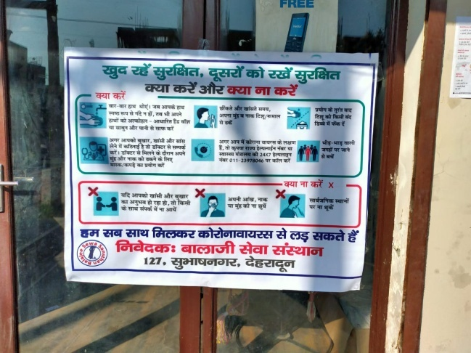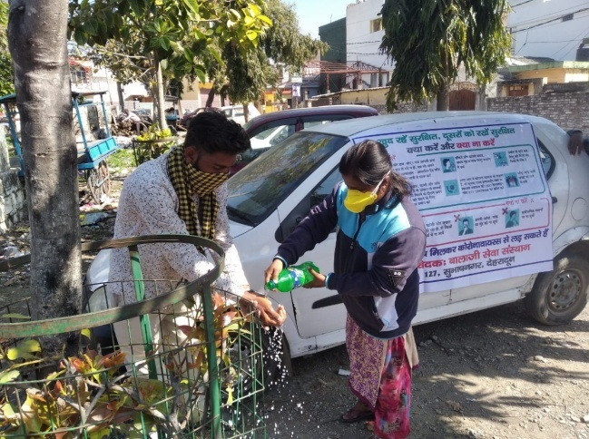

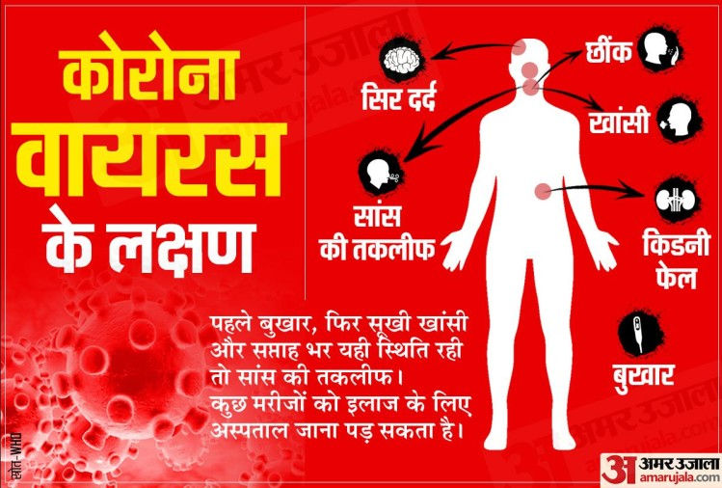

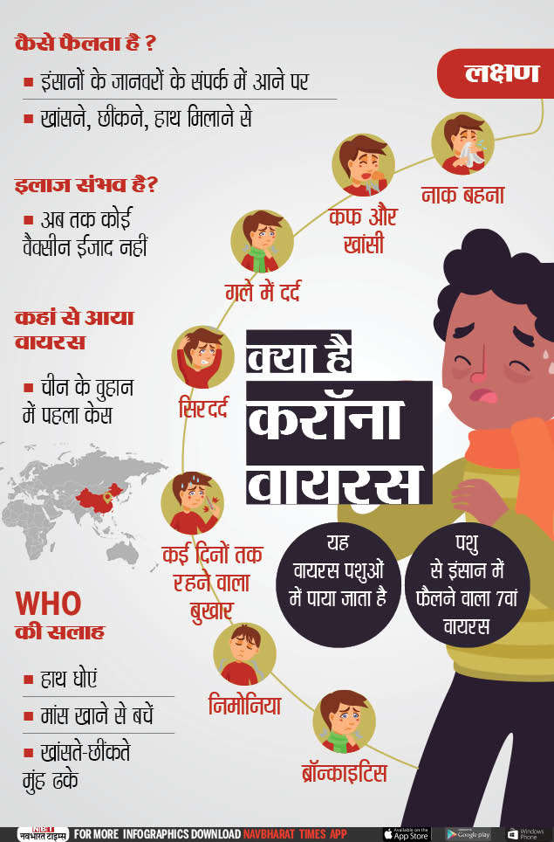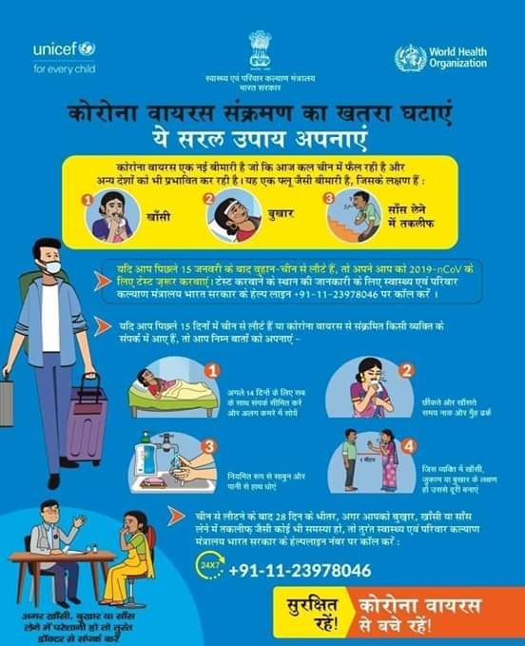

(Note: We are using IEC material developed by the Ministry of Health and Family Welfare)

